Assignment -1

Python Programming

|  |  |
| --- | --- |
| Assignment Date | 19 September 2022 |
| Student Name | R. KOWSHALYA |
| Student Roll Number | 511319106021 |
| Maximum Marks | 2 Marks |

QUESTION-1:

**Build a smart home using tinkercad, take any sensors (atleast 2) and use LED & Buzzer.**

CIRCUIT DIAGRAM

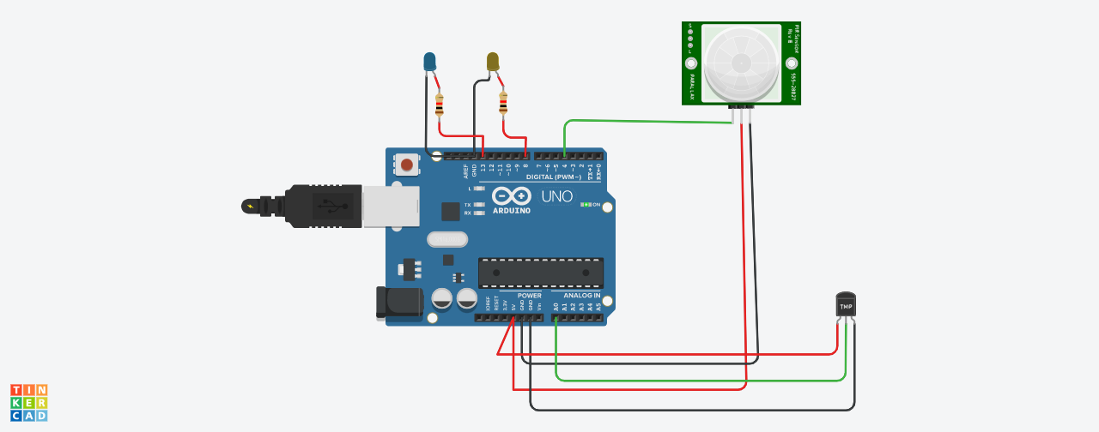

CODE

void setup()

{

Serial.begin(9600);

pinMode(4,INPUT);

pinMode(8,OUTPUT);

pinMode(13,OUTPUT);

}

void loop()

{

int p=digitalRead(4);

Serial.println(p);

if(p)

{

digitalWrite(13,1);

Serial.println("motion detected");

}

delay(1000);

double a=analogRead(A0);

double t=(((a/1024)*5)-0.5)*100;

Serial.println(t);

if(t>25)

{

digitalWrite(8,1);

Serial.println("temperature greater than 25");

delay(1000);

}

}